**Applied Machine Learning**

**Group Practical Project**

**IoT Intrusion Detection Competition using Machine Learning**

**Alberto Matuozzo, David Kirby, Adam Elshimi, Ali Sahin and Andrew Robinson (13122132)**

**Student Numbers**

**Introduction**

The Internet of Things (IoT) is a paradigm that involves networked physical objects with embedded technologies to collect, communicate, sense and interact with the external environment through wireless or wired connections. With rapid advancements in IoT technology, the number of IoT devices is expected to surpass 50 billion by 2020, which has also drawn the attention of attackers who seek to exploit the merits of this new technology for their own benefits [1]. The aim of this project is to address the issue of security threats in IoT devices by building a predictive machine learning model to distinguish between “intrusive” traffic, called intrusions or attacks, and “good” normal traffic. The predictive machine learning model will focus on detecting impersonation attacks in a reduced CLS portion of the Aegean Wi-Fi Intrusion Dataset (AWID) which was originally prepared and managed by George Mason University and the University of the Aegean.

**Planning**

Given the tight timeline of the project, the team agreed it was imperative to outline the project plan as quickly as possible. As such, a total of 8 tasks were defined and assigned to the members of the team. A deadline of 12th December was set for all literature research and practical programming to be completed, the idea being to put some time aside for fine-tuning the machine learning models and writing up each task before the project deadline.

The 8 tasks were assigned as follows:

* Task Assignment – Group Discussion
* Planning – Group Discussion
* Searching Literature – Each group member to read around their assigned task and record references.
* Pre-Processing – Alberto Matuozzo
* Selecting Features – David Kirby
* Exploring and Selecting Machine Learning (ML) Algorithms – Adam Elshimi
* Refining Algorithms – Ali Sahin
* Evaluating and Analysisng the Results - Andrew Robinson

In addition to the above it was agreed that GitHub would be used to develop and store our project pipeline and other documents and that all code would be written using Juypter notebooks. Furthermore, the below Gantt Chart was put togther to provide an overview of the project timeline: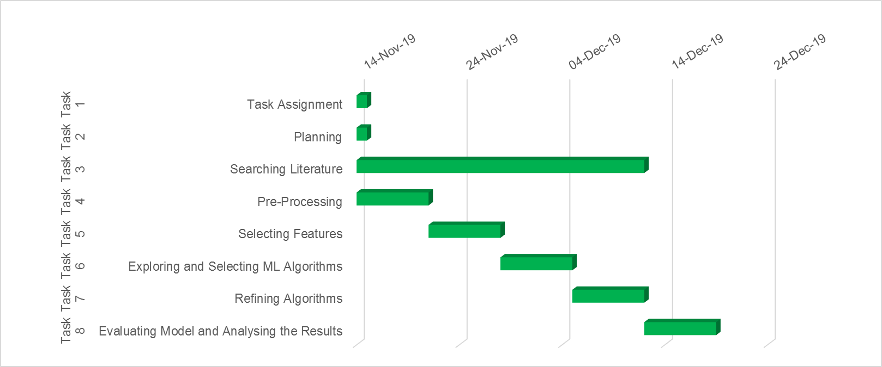

**Pre-Processing - Alberto Matuozzo**

**Selecting Features - David Kirby**

**Exploring and Selecting Machine Learning Algorithms - Adam Elshimi**

**Refining Algorithms - Ali Sahin**

**Evaluating Model and Analysing the Results – Andrew Robinson**

**Future Work**

**References**

[1] X. Du, H. Chen, L. Zhu, J. Li and Z. Chang, "Security and Privacy in Wireless IoT," in IEEE Wireless Communications, vol. 25, no. 6, pp. 10-11, December 2018.

**Appendix**